23

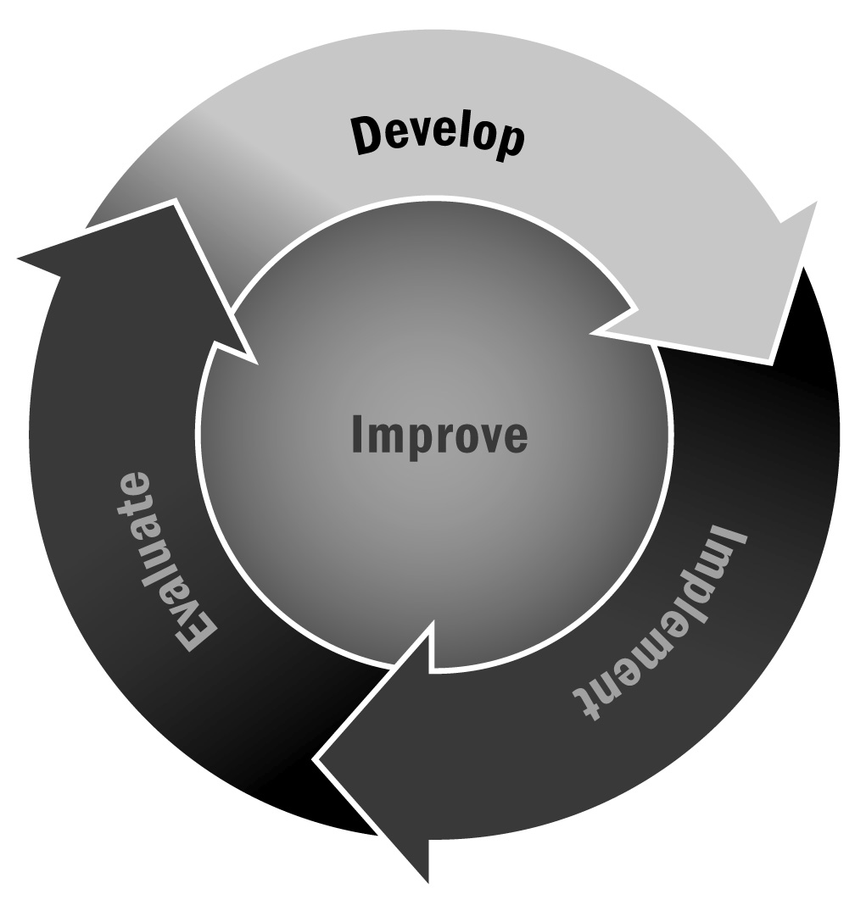
Professional Development Plan
In Chapter 1, you learned that professional development is an umbrella name for the variety of learning opportunities staff members can engage in as a part of their job. Prioritizing high-quality, consistent, and responsive professional development will develop the capacity of staff members to implement quality activities.
Directions: This form can be used to develop professional goals and professional development strategies to help staff members achieve identified goals. Use it in multiple ways. Perhaps encourage staff members to reflect on possible performance and development goals and complete this form together, or have program leadership complete this form for staff members and then review and revise it together. Staff members should be given the opportunity to update their professional development plan at the end of each program cycle or about every six months, and their plans should be included in performance reviews to monitor and develop staff members’ capacity in their role.
Employee Name:
Employee Position Title and Group/Area:
Supervisor Name:
Supervisor Title:
Date Completed/Date of Next Review:

What?  Developmental Goal | Why?  Reasons for Goal | How?  Strategies/Resources to Achieve Goal | When?  Target Date

Examples of strategies to achieve goals:
- Attend an afterschool and expanded learning conference
- Take a class at a university or accredited institution
- Attend a training course or a course in a specific academic content area
- Meet regularly with colleagues to discuss teaching and learning
- Visit other afterschool and expanded learning programs
- Subscribe to a journal or newsletter to stay current on research and activities

